**IgniteSTEM**

NEW YORK CITY

**RESOURCES**

**Contents of this booklet**

*Introduction: Message from the Team*  2

*Four Ways to Engage Your Students in STEM*  3

*Product Guide for Robotics in the Classroom*  5

*The Beginner’s Guide to Makerspaces in the Classroom* 10

*The Beginner’s Guide to Design Thinking in the Classroom* 17

*HackTJ’s Tips for Organizing a Hackathon*  25

*Summer of Creativity: Teacher Reading List*  32

**Introduction: Message from the Team**

*Dear Reader,*

*This booklet is packed with some amazing resources that we at IgniteSTEM hope you will love. Many of our team members did not get the STE(A)M opportunities they would’ve wished to have at their schools, and together we hope to make this crucial part of education to as many students as possible. A change like this can only occur if lead by the most amazing educators and administrators, and we would therefore like to thank you for being part of our mission.*

*In a society that changes fast every day, we are in need of a new generation of problem-solvers. The skillset required by our societal needs is never fixed and will always keep involving, putting a large strain on schools and educators to keep updating their curriculum. We understand that any help in that process is welcome, and therefore we like to contribute our part by providing you with resources that you can apply to your school or classroom.*

*We again thank you for your interest in IgniteSTEM and we hope that our resources and conference are useful to you. As we’re always looking to improve and be more helpful, we’re open to any feedback, questions or concerns you might have. Feel free to contact us at any time. Together we will bring STE(A)M to all classrooms in the United States and beyond!*

*Best,*

*The IgniteSTEM Team*



**Four Ways to Engage Your Students in STEM**

Adapted from Emma Banay’s article (Design2Learn Program Manager)

Does your program struggle to keep students interested and engaged in STEM activities? Community educators at a recent STEM training shared that they needed “more of a hook to involve students and keep them engaged” and that they found students disengaged “if they do not find the content relevant to them.” Some sites also shared that, unfortunately, some kids “don’t like science or think it is boring, so they shut down even before” the lesson can begin.

Sound familiar?

Tackling this challenge is at the heart of Design2Learn, whose mission is to determine whether extra time + collaboration between classroom and after school + design-based learning improve student engagement and achievement in STEM subjects.

In response to this challenge, Design2Learn educators have been working hard to boost students’ interest and engagement in STEM by using strategies that promote participation, youth voice, relevance and positive relationships in their activities. How do these strategies spark STEM interest? **See these tried-and-true approaches, straight from Design2Learn classrooms:**

**Participation**

You can spur high levels of participation with fun, high-stakes testing. In one classroom, students were challenged to design a “soft landing” system that would protect a raw egg from breaking. The catch? You break it, you clean it up! Kids were excited to test their designs with a real egg and took the engineering design process even more seriously to avoid clean-up duty.

**Youth Voice**

Disappointed by students disengaging during STEM lessons, the educator team a certain school passed out a survey asking students what activities and topics they’d be excited to explore in Design2Learn. Now educators are using the survey results to plan activities for the rest of the year, like the “Textbook Challenge.” In this activity, students were challenged to build a table out of just paper and tape to support one textbook. Students took the challenge and ran with it: the winning group held up a whopping 33 textbooks! Honoring students’ interests and ideas allows them to shape the activity and feel a sense of responsibility and ownership.

**Relevance**

Activities become more relevant to students when they connect to students’ own lives, cultures and interests. At a particular school, students designed water filters after learning about the Flint, Michigan water crisis and contamination at some NYC schools. Try picking activities that you know will connect with students’ broader lives, or—better yet—ask them what issues, interests, or topics from their own lives they’d been interested in exploring in a STEM activity.

However, as STEM is more broad than must of your students might realize, it’s not necessary to explicitly ask for STEM interests. Rather, simply ask the general question of what is currently interesting your students and then try to apply these to a STEM activity. While this can be challenging, a simple google search on a topic raised by a student can give you may ideas on how to apply it to an aspect of STEM. In this way, you can engage your students with STEM in an unexpected way, having them realize by themselves that what they’re passionate about is STEM-related, rather that you telling them how interesting and cool STEM can be.

**Positive Relationships**

Another way to boost student engagement in STEM activities is by making those activities a fun and positive place to be. Warm relationships among students and between students and educators makes a safe environment where students are more willing to take risks, engage with material, and explore their interests. Highland Park Community School/Cypress Hills Local Development Corporation explicitly promoted teamwork skills, giving students a “teamwork checklist” to complete as part of their design challenge. Students had to create and test and popsicle-stick bridge and convince their educators that their team demonstrated the teamwork skills on their checklist.

This is a point where many classrooms fail to succeed; Students end up making things by themselves rather than within a team. One way of promoting teamwork relationships is by having students design, build or create something that consists of multiple distinct elements; Each student can take on an element, but eventually all the elements have to fit together. This forces students to engage with what their teammates are working on, adapting their work to make all the parts fit together in the end.

PRODUCT GUIDE FOR

**ROBOTICS**

IN THE CLASSROOM

**Product Guide to Robotics in the Classroom**

By IgniteSTEM Content

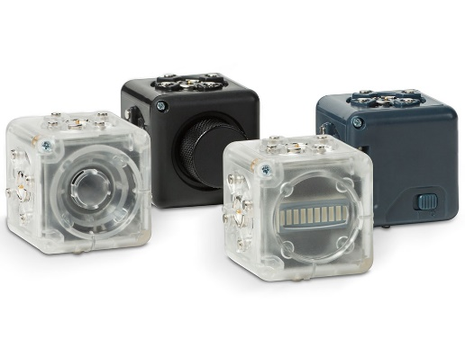**Cubelets**

Cubelets are magnetic blocks that you can snap together to make an endless variety of robots with no programming and no wires. Cubelet-based robots can drive around on a tabletop, respond to light, sound, and temperature, and have surprisingly lifelike behavior.

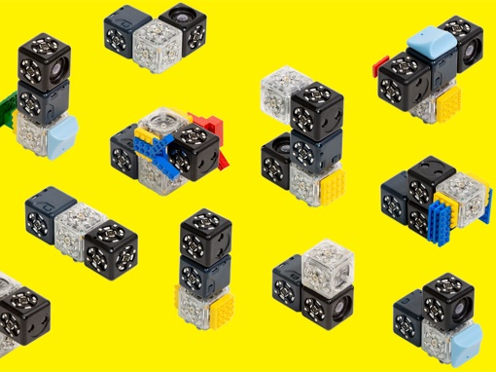

*Features*

Modular design with magnetic faces for easy building. Each Cubelet is pre-programmed for a specific function that enables sensing, thinking, or acting. Powered by a single rechargeable Cubelet battery. Programming via Blockly or C. Features free educator resources online. Discovery Kit includes a Bluetooth Hat, which pairs robot creations with mobile devices.

**Cost: $140 For the Discovery Set**

Website: [www.modrobotics.com](http://www.modrobotics.com)

**Dash and Dot**

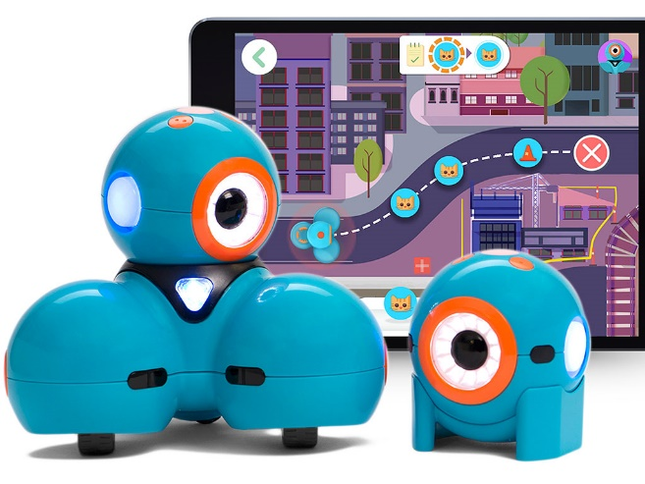Dash is a small mobile robot that is full of character and drives around making noises and shining lights. Dot is its sidekick, and it, too, is full of character. The robots help kids learn the basics of robotics and coding at home or in classroom settings.

*Features*

For ages 6 and up. Bluetooth Smart 4/LE; charging via micro USB; compatible with a wide range of apps, including Go, Wonder, Blockly, Path, and Xylo. Dash only: Detects voice commands and other robots, has front and rear object detection.

**Cost: $150 (Dash), $50 (Dot) Also available as a classroom pack**

Website: [www.makewonder.com](http://www.makewonder.com)

**Koov**

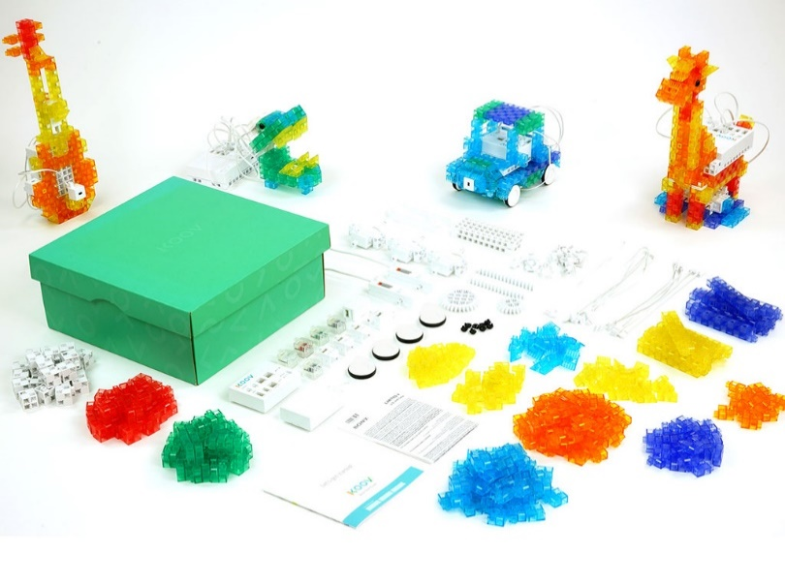KOOV is a hands-on educational kit for coding, robotics, and design. It includes colorful blocks, sensors, actuators, and a microcontroller. Easy to follow instructions and visual programming let kids start building and coding quickly.

*Features:*

KOOV Educator Kit: 322 building blocks, plus light sensor, push sensor, accelerometer, DC motors, servo motors, LED modules. Arduino-based microcontroller. Drag and drop visual programming. Lesson plans and educator guides.

**Cost: $520 (Educator Kit)**

Website: [www.sony.com/koov](http://www.sony.com/koov)

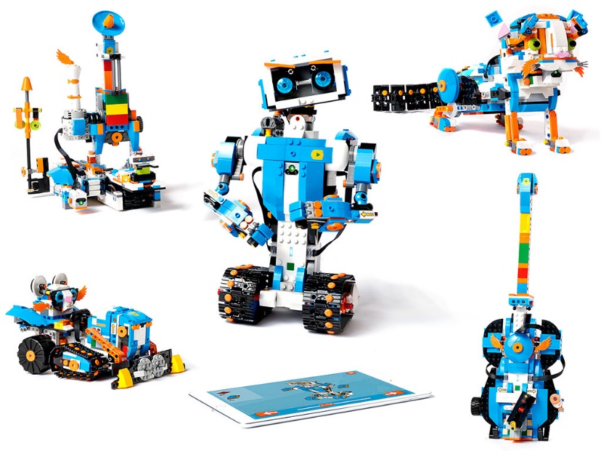**LEGO Boost**

Lego Boost is a building and coding set that lets you create robots and other models out of Lego bricks. Simple programming helps you add sound, movement, and personality to your creations.

*Features*

Includes 840 parts, with building instructions for five models (robot, rover, guitar, pet, and production line). Comes with a Graphical programming environment and app.

**Cost: $159.99**

Website: [www.shop.lego.com/en-US/](http://www.shop.lego.com/en-US/)

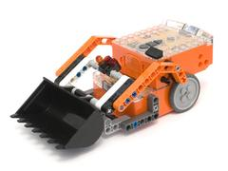**Edison**

The Edison robot is a powerful, engaging tool for teaching kids STEM, computational thinking and computer programming in a hands-on way. Edison is a programmable robot designed to be a complete STEM teaching resource for coding and robotics education for students from 4 to 16 years of age.

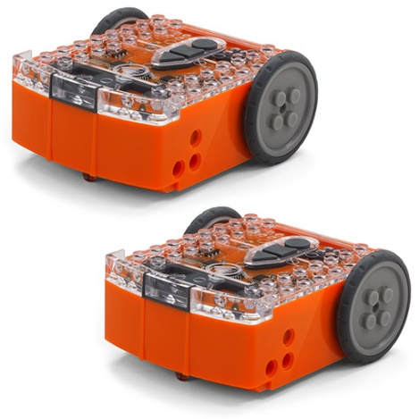

*Features:*

Edison Can respond to light and sound, follow lines and avoid obstacles, communicate with other Edison robots, and connect to other Edison robots and LEGO bricks. Works with barcodes and remote control (ages 4+), graphic coding (ages 7+), Scratch programming (ages 10+) and Python (ages 13+)

**Cost: $53.90 (EdPack 1)**

Website: [www.meetedison.com](http://www.meetedison.com)

**Ozobot Evo**

The Ozobot Evo allows your students to play while learning coding and logic skills. Ozobot can be programmed to move around the classroom as well as to do more complex activities! Interact as Evo shows off a series of tricks—all built with code. Connect to the Evo app (iOS/Android) to earn points and level up for all the ways you code, create, and play with games and tricks.

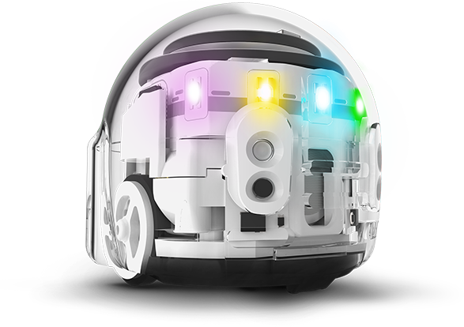

*Features*

Teach yourself to code Evo two ways: online with OzoBlockly and screen-free with Color Codes. OzoBlockly, powered by Google’s Blockly, has five skill levels for beginner to master coding. Color Codes, made with markers on paper, teach basic STEAM skills, critical thinking, and debugging. Includes: 1 Evo robot, Educator Bot Camp, 1 charging cable, 4 Color Code markers, access to 150+ free STEAM lessons.

**Cost: $99 (Evo Educator Entry Kit)**

Website: [www.ozobot.com](http://www.ozobot.com)

**MakeBlock mBot**

mBot is a STEAM education robot for beginners, that makes teaching and learning robot programming simple and fun. With just a screwdriver, the step by step instructions, and a study schedule, children can build a robot from scratch. As they go, they will learn about a variety of robotic machinery and electronic parts, acquire the fundamentals of block-based programming, and develop their logical thinking and design skills.

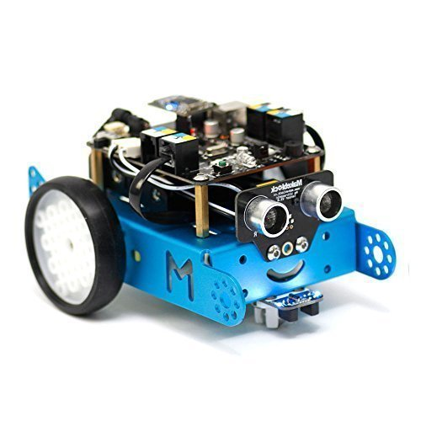

*Features*

Two programming tools: Arduino IDE and mBlock, a drag-and-drop programming tool based on Scratch 2.0. The mBot has an aluminum chassis, strong and compatible with Makeblock & Lego parts. Free lessons are provided and increasing continually. Projects like wall avoidance, line following, games with other mBots, using sensors to play games in Scratch.

**Cost: $79.99 (Robot Kit)**

Website: [www.makeblock.com](http://www.makeblock.com)

**Root**

Root is a little mobile robot designed to teach kids logic and coding skills. It draws, plays music, lights up, and can drive on metal-backed whiteboards with the help of magnets in its belly. Root won Best Toy at 2018 CES.

*Features*

Root is capable of climbing and navigating on classroom metal-backed whiteboards. Progressively challenging programming levels, beginning with graphical interface. Works with dry-erase markers, and can also erase.

**Cost: $199**

Website: [www.rootrobotics.com](http://www.rootrobotics.com)

THE BEGINNER’S GUIDE TO

**MAKERSPACES**

IN THE CLASSROOM

**The Beginner’s Guide To Makerspaces in the Classroom**

**By Angela Watson, adapted from** [www.thecornerstoneforteachers.com/makerspaces](http://www.thecornerstoneforteachers.com/makerspaces)

**Makerspace is a rapidly growing trend in schools across the country, but to be honest, I’ve never implemented one myself, and I can’t quite picture the logistics of orchestrating a Makerspace. How do kids know what to do? How can you find out what they’re learning? How do you make time for that with all the other tasks crammed into the school day? And how do you keep the Makerspace from turning into a chaotic mess?**

**I wanted to get answers to these questions from teachers who have extensive Makerspace experience, and not just at the secondary level. So, I invited Cheryl Nelson and Wendy Goldfein of**[Get Caught Engineering](http://www.getcaughtengineering.com/)**to share how they’ve managed Makerspaces in their own classrooms and helped other elementary and middle school teachers get started, too. Thank you, Cheryl and Wendy, for sharing your experiences below!**

**What exactly is a Maker and what happens in the “space”?**

If you search a thesaurus for the word “make” you will find a plethora of great synonyms: create, cause, assemble, manufacture, achieve, invent, generate, produce, craft, build, construct, or generate. And that is exactly what happens in a Makerspace. It is truly an environment where one is only limited by one’s imagination. It mixes all aspects of STEM–Science, Technology, Engineering, and Math–and sprinkles it with imagination for an exploration of “what if.”

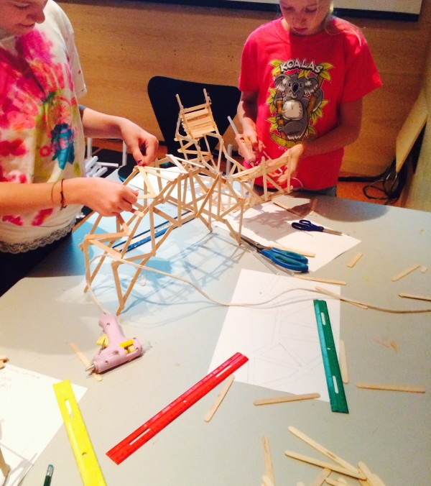As we have integrated engineering lessons into our classrooms, we have watched as kids come up to us and asked, “Mrs. G, are there extra popsicles sticks? May I have them?” “Mrs. N, can I have this extra wire? Do you have any extra magnetic tape?”And when asked, ”Why do you want these items?” the answer invariably was “I just would like to build something with it.”  The desire to gather “stuff“ in order to “create things” became commonplace with our students.

With those experiences in mind, we started paying more attention to the Maker Movement and came to the conclusion that having a Maker Space in our classroom would be a perfect catalyst for developing problem solving skills with our students.

**What materials do you use in a classroom Makerspace?**

Although it would be really neat to have some of the more expensive tools that many Maker Spaces have, like 3-D printers and Little Bits Electrical Kits, we settled on creating a space that used simple items found around the house, classroom, and school, including recyclables and throw-a-ways. A Maker Space can be created with materials as simple as sheets of paper, some tape and paperclips, to create amazing contraptions like these:

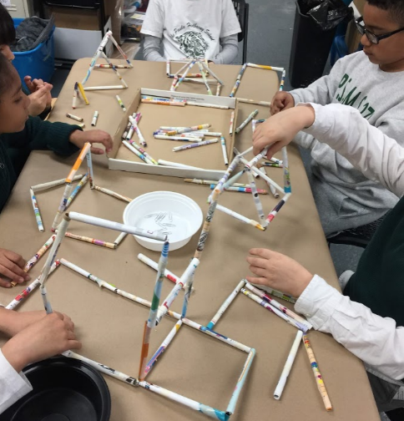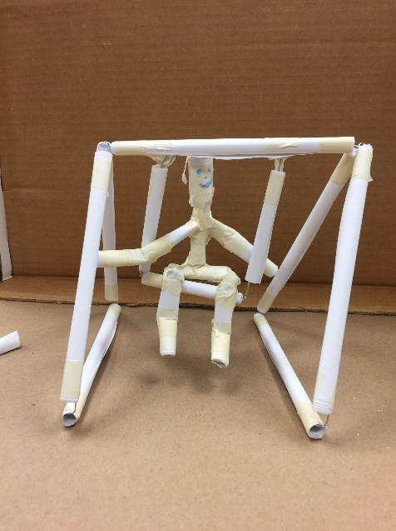

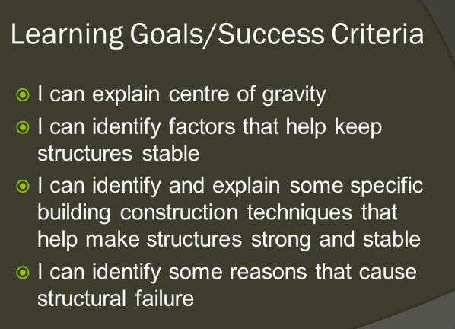On a side note, these contraptions provide a great opportunity to teach students about elementary physics and engineering concepts, including the center of mass, gravity, forces, and the stability of structures. When having students build a certain structure, the following learning objectives can be a good example:

Source: [https://slideplayer.com/slide/3972646/](https://slideplayer.com/slide/3972646/6)

Rather than have students just gather up a lot of materials to glue or tape together, we developed task cards that would provide brain push-ups and explore possible projects that interested them. Students chose something that interested them to work on. They were then allowed to draw a picture of what they imagined, build a prototype for their idea, or actually create and make a finished project.

The projects were widely varied: crocheting a hat for a cat;  constructing a desk organizer; making a mock-up of a state-of-the-art lunch tray, and an alarm for treasure box. Some students wanted to create and some wanted to investigate. Taking apart old donated cell phones or toys was popular. All choices provided the students with problem solving opportunities.

**How do students know what to build in the Makerspace?**

As we developed our Makerspace center, we quickly realized that Makerspaces and children are a natural combination. Children are tinkerers. They enjoy taking things apart to see how they work and being challenged to put it back together. By providing an array of materials, they can create something unique that has never been seen before.

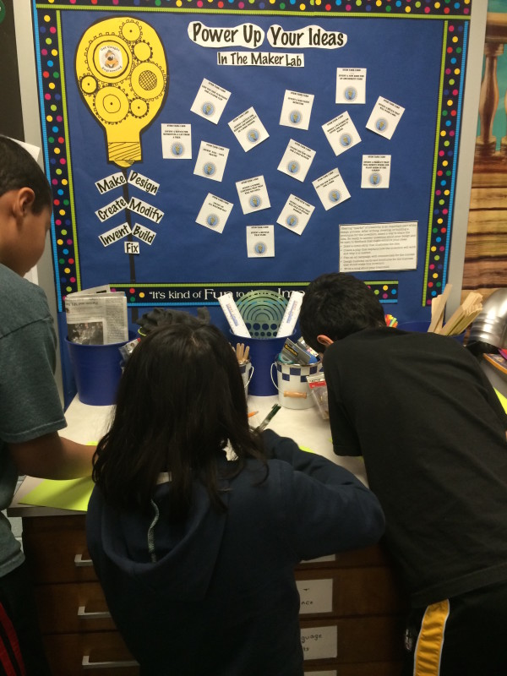In a classroom Makerspace, students have the freedom to explore their own interests and to come up with their own projects that they would like to create. Given this freedom, students direct their own learning by delving into topics that they need to learn about to make their project successful:

Want to build an alarm? Time to review circuits and switches.

Want to create a small hat? Time to learn to sew or crochet.

It becomes a real-world inspired motivation to learn more and delve into research or track down primary source interviews from those “in the know.”

**How do I find the time for students to use a Makerspace?**

We decided to keep things very simple in our classrooms and create a Maker’s Space as a center. Students could pursue interests and begin a project of their own choosing. For those needing inspiration, these [**task cards**](https://www.teacherspayteachers.com/Store/Get-Caught-Engineering-Stem-For-Kids) with suggestions were provided.

**The Maker Space is essentially open all day for students to continue their projects when regular classwork is completed.** The Space is particularly busy on days when outdoor recess is impossible.

**What do I need to get started with a Makerspace?**

Beginning a Maker’s space doesn’t mean that you need to max out your or the school’s credit card buying tons of materials. To begin with, stock the space with items that are typically found around the house or school – small and larger boxes, paper towel and toilet paper tubes, egg cartons, masking and duct tape, as well as liquid and stick glue.

Ask for donations from parents for other items such as wire, yarn, toothpicks, cups, recycled plastic containers. We have found that the best type of cardboard for ease of cutting are cereal boxes. Tools needed will include screw drivers (flat head and Philips head), pliers, and scissors. You may need to purchase items such as feathers, pipe cleaners, brads, and craft sticks, but don’t hesitate to add those items to a donation request from businesses or parents.

If possible, try to include old toys or small electronics to be taken apart or help kids discover how things work. Broken toys can also be supplied for students to repair, furthering their knowledge of how things work.

**How can I make sure students are learning and not just wasting supplies?**

Good questions. Yes, thinking can be untidy, tinkering can generate clutter, and testing ideas can create a muddle. You do not want your Maker Space to just become a  “Let’s Make A Mess and Walk Away” Center.  Planning ahead on your part and their part will alleviate headaches later.

To help control the consumption of supplies, we strongly suggest that students first create a detailed plan for their project. By having a detailed, labeled drawing and a list of projected materials provided to the teacher, wasted materials are reduced. This also ensures that the student has carefully thought out, researched, and planned the project.

**How do I start a Makerspace in my classroom?**

Ready to give it a try? Here’s your Makerspace to-do list:

1. **Select an area for your Makerspace.**You want room for 3-4 students to work, and a display area for project ideas and a sturdy table.
2. **Gather storage containers.**We love to shop at hardware stores for ideas. (Did you know you can buy empty paint cans? Those are marvelous for storing various tools.) We also shop at the dollar store for assorted bins and baskets that are reasonably priced. Think carefully about where you will store extra supplies. There is nothing quite as exciting as receiving five huge trash bags of recycled items at 8:00 AM and having nowhere to put them except behind, in front, and on top of your desk!

And that reminds us…become VERY good friends with all of the custodians. They are the experts at helping you find locations to store extra items, as well as making sure that your “treasures that look like trash” don’t get tossed out. (We know the favorite type of homemade cookies for every one on our custodial staff…just sayin’.)

1. **Send out a donation letter for items you would like.** Letters can not only go to parents and grandparents, but stores and associations and agencies, too. Really search your community for possible connections. We developed no fear in approaching anyone and everyone for items. (Did we mention the 1,000 ping pong balls, wooden spools and paint stirrers that a group donated and DELIVERED to us? Three years later, we are still making catapults with that amazing donation.)
2. **Put donations away as soon as they come in.** No excuses. Really. Trust us. We know two words: organized chaos!
3. **Create a poster with rules for your center.**Keep it simple. We suggest: “Plan. Persevere. Put Away.” Hint: Make keeping the Makerspace organized one of your classroom jobs.
4. **Create an Open and Closed sign as well as a sign up sheet for the Makerspace.**
5. **Hang an inventory list nearby so that the students can indicate when certain consumables are beginning to run low.**
6. **If possible, solicit adult volunteers to be the docents for the Makerspace.** This will make your life easier, but is not necessary for a successful Maker Space.
7. **Make a wish list for big items such as a 3-D printer or Makey-Makey kit and keep your eyes out for small grants that can help you obtain those items.** Have a “nothing ventured, nothing gained” attitude and don’t be afraid to give grants a try for things you would like to add. We regularly post small grant opportunities that are easy to write on our [*Get Caught Engineering Facebook page*](https://www.facebook.com/GetCaughtEngineering)*.*

**What Makerspace resources do you recommend?**

Need inspiration and back up support for your plans? The Maker Movement has inspired lots of reference books to help justify the concept, design a space, and plan activities. Our favorites include:

* **The Art of Tinkering**by Karen Wilkinson and Mike Petrich
* **Tinkering: Kids Learn by Making Stuff** by Curt Gabrielson
* **Making Makers: Kids Tools and the Future of Innovation** by AnnMarie Thomas
* **Making is Connecting** by David Gauntlett
* **The Invent to Learn Guide to Fun** by Josh Burker

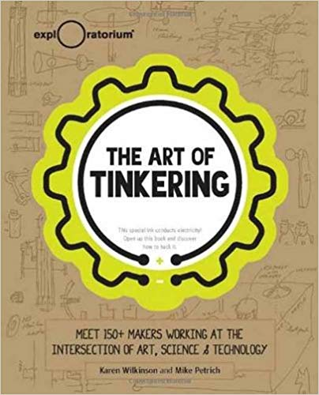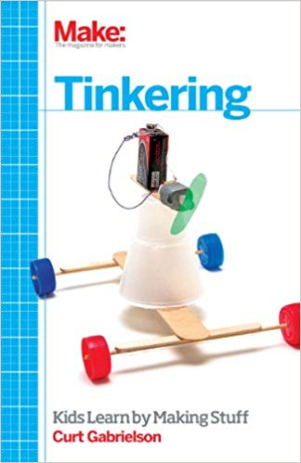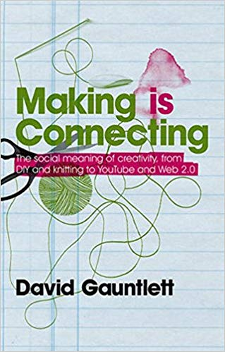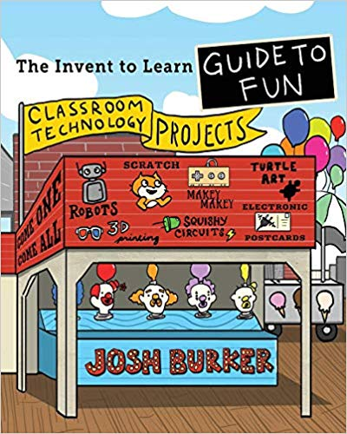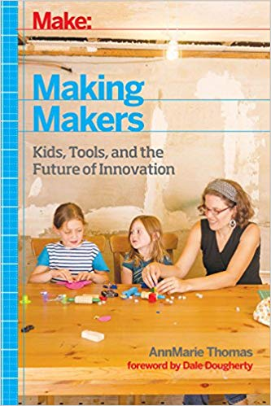

It is our hope that Makerspaces become as central to a classroom as a reading corner or a math manipulative shelf. Flexible thinking, problem solving, collaboration are all 21st century habits that a Makerspace can provide for you and your students. Providing an environment where students can create and dream of new ideas is the best way to instill those skills. And besides, as the famous creator and ultimate maker Walt Disney once said, “It’s kind of fun to do the impossible!”

THE BEGINNER’S GUIDE TO **DESIGN THINKING**

IN THE CLASSROOM



**The Beginner’s Guide to Design Thinking in the Classroom**

By AJ Juliani, adapted from [www.ajjuliani.com](http://www.ajjuliani.com)

In the first post of this series, I shared my biggest fear as an educator (being ineffective and my students not caring about learning). We looked at the role choice, inquiry, and ownership play — in not only engaging our students — but also empowering them to intrinsically care about what they can learn and do in school.

But giving my students choice and allowing them to being curious learners was hard work. In fact, sometimes I was still really ineffective at guiding the learning that was taking place in my classroom. I tried many different project-based learning frameworks, embraced the inquiry cycle, and tweaked my own idea of how to structure this type of innovative and creative work.

My research (and trial and error as a teacher) led me to design thinking (most noticeably the work of Stanford d.school and IDEO). It was through design thinking that I found a process and methodology that worked for all kinds of complex problem solving and creative work. In this article, I’ll take you on a tour of design thinking. It’s the process that I’ve used countless times as a teacher, curriculum leader, technology coach, author, and entrepreneur. Here’s what we’ll cover:

1. **What is Design Thinking (and the LAUNCH Cycle)?**
2. **How is design thinking used around the world?**
3. **How can I use design thinking in (and out of) my classroom?**

**1. Design Thinking is the process**

Design thinking provides a way to think about creative work. It starts with empathy, working to really understand the problems people are facing before attempting to come up with ideas and create solutions.

It’s a bit of a debate where design thinking originated. Some claim that it started in the sixties with *The*[*Sciences of the Artificial*](http://www.amazon.com/gp/product/0262691914/ref=as_li_tl?ie=UTF8&camp=1789&creative=390957&creativeASIN=0262691914&linkCode=as2&tag=educarethi03-20&linkId=ZINB76AIAYYXK4IM)*.*Others point to [*Design Thinking*](https://www.blogger.com/%3Ca%20href=%22http:/www.amazon.com/gp/product/026268067X/ref=as_li_tl?ie=UTF8&camp=1789&creative=390957&creativeASIN=026268067X&linkCode=as2&tag=educarethi03-20&linkId=VKXVJKA2DDGQHUJW%22%3EDesign%20Thinking%3C/a%3E%3Cimg%20src=%22http://ir-na.amazon-adsystem.com/e/ir?t=educarethi03-20&l=as2&o=1&a=026268067X%22%20width=%221%22%20height=%221%22%20border=%220%22%20alt=%22%22%20style=%22border:none%20!important;%20margin:0px%20!important;%22%20/%3E)*,*which focused more on urban planning and architecture. Still others point to Robert McKim’s work in [*Experiences in Visual Thinking*](http://www.amazon.com/gp/product/0818504110/ref=as_li_tl?ie=UTF8&camp=1789&creative=390957&creativeASIN=0818504110&linkCode=as2&tag=educarethi03-20&linkId=VYV4ONNFRWSZ3PJJ)*.*Like all great ideas, it has been an evolution, influenced by thousands of people. We know that our work around Design Thinking has been influenced by people like Tom and David Kelley, Tim Brown, John Maeda, Peter Rowe (as well as organizations like Stanford d.school and IDEO).

**Different interpretations of the phases in Design Thinking**

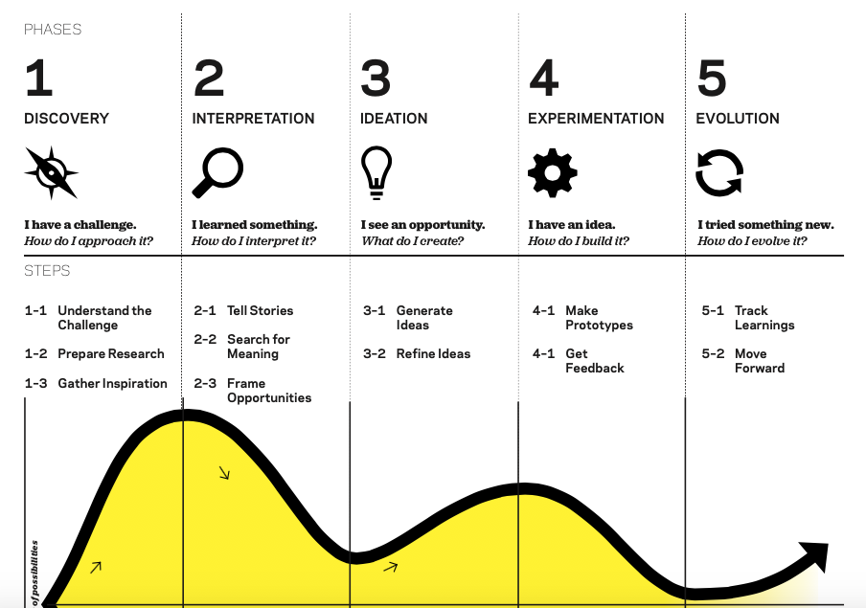Here are the phases of Design Thinking as described in IDEO’s “Design Thinking for Educators” toolkit (an awesome resource):

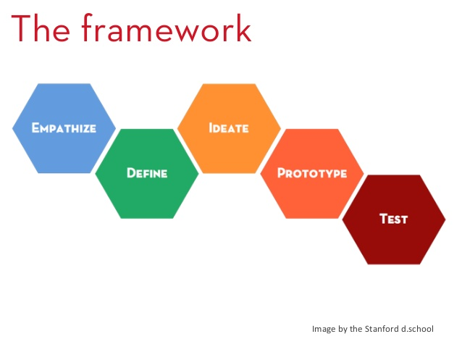Here are the phases of Design Thinking as shared by Stanford d.school (and they again have fantastic resources):

And there are other models, frameworks, and descriptions of the design thinking phases from various organizations and universities:

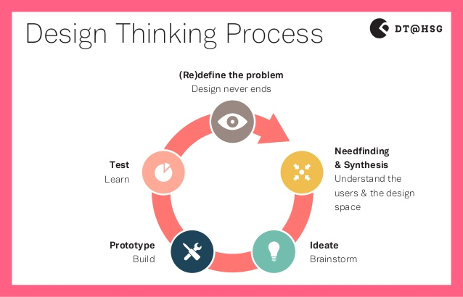

I began to use the design thinking process during 20% time and Genius Hour projects. I helped other teachers structure their inquiry projects filled with choice around the design thinking process. I saw the process as a new way to develop lessons, units, projects and curriculum.

When I got into a conversation about design thinking with John Spencer (who was also using the process as a classroom teacher), we both agreed that the biggest struggle we had when using design thinking and sharing the process with other educators was it’s implications for K-12 students. What did we do about this problem? We began to try and solve it using the design thinking process.

We looked at the terminology used, the sample exercises and activities available, and how teachers and students responded to the different phases. We talked with teachers using design thinking in their classrooms and met with those that wanted a framework for creative work. Then we started to design and build out an idea. We highlighted what worked and kept on revising.

The end result was “The LAUNCH Cycle”, a K-12 framework for design thinking in the classroom!

**The LAUNCH cycle is the framework**

The LAUNCH Cycle is not a formula. It is not a step-by-step guide to being creative. However, we’ve used the LAUNCH Cycle framework to make creativity an authentic experience time and time again in our classrooms.

The LAUNCH Cycle outlines creative work from start to finish. From listening and learning, to navigating ideas, to highlighting what works, the LAUNCH Cycle builds capacity and clarity for teachers and students who are making, building, tinkering, and creating. The final piece of the LAUNCH Cycle is what sets it apart: actually launching your creation out into the world!

**2. Design Thinking is used (almost) everywhere**

Let’s take a look at the growth of the term “design thinking” using Google’s Ngram Viewer:



*A graph of occurrence of the term 'design thinking' over the years.*

The term has jumped in explosive growth. Design thinking is used at universities, in organizations, by artists and designers, by engineers, and by many in the business/corporate world.

While design thinking was originally used in many cases to design products, it is now being used to tackle big problems in all kinds of sectors. A recent article in the Harvard Business Review titled, “[Design Thinking Comes of Age](https://hbr.org/2015/09/design-thinking-comes-of-age)“, takes a look at the growth and how this design mindset has grown exponentially over the past few decades.

[Wikipedia’s article on Design Thinking](https://en.wikipedia.org/wiki/Design_thinking) is a wealth of resources from the timeline of use, to the different industries that are using it, to its influence on corporate structure. David Kelley, who is the founder of the design firm IDEO as well as Stanford d.school’s Institute of Design (and author of *Creative Confidence*) puts the benefits of design thinking into a simple statement:

*“We moved from thinking of ourselves as designers to thinking of ourselves as design thinkers,” he continues. “What we, as design thinkers, have, is this creative confidence that, when given a difficult problem, we have a methodology that enables us to come up with a solution that nobody has before.”*

Design thinking is used by so many varying industries because of this statement. It provides a methodology for creating innovative solutions to all kind of difficult problems.

**3. Design thinking in your classroom**

In IDEO’s “[Design Thinking for Educators](http://www.designthinkingforeducators.com/)” Toolkit they look at a number of different examples of design thinking in the classroom. Here’s one example:

*“The faculty at Ormondale Elementary School in California wondered if they were preparing their students well for the future. They decided it was time to corroboratively design an approach to teaching and learning that they felt was updated and relevant for the 21st century.*

*Collectively, they embarked on a design journey and came to an approach they call “Investigative Learning”, which addresses students not as receivers of information, but as shapers of knowledge. The faculty continues to evolve and share this approach with new teachers through the creation of a Manual of Investigative Learning to keep track of their philosophy and methods. They have gained support from their school board, and have become recognized as a California Distinguished School.*

***The faculty at Ormondale Elementary School uses design to address the needs of their evolving student body.”***

This is the interesting thing about design thinking. It can be used for entire school problem-solving or projects in a specific classroom. At Mount Vernon School they’ve embraced design thinking as a way to [scale authentic learning](http://www.mvifi.org/deepdt/) in younger grades (K-5) and upper grade levels (6-12):

*“In 2014, a team of MVIFI (Mount Vernon Institute for Innovation) designers embarked on a design challenge to scale the DEEP methodology into tools for design thinkers to use. Inspired by IDEO and Stanford’s d.school, this playbook has been used all over the country in various industries to inspire people-centered problem solving. We have decided to offer this playbook, which includes a design thinking introduction called a Flashlab, free of charge under*[*Creative Commons Attribution-NonCommercial-ShareAlike License.*](https://creativecommons.org/licenses/by-nd/4.0/)*”*

At [Germantown Academy](http://www.germantownacademy.net/academics/innovation-special-programs/design-thinking/index.aspx), Director of Innovation Gaby Russomagno has worked with staff to develop a design thinking mindset, and they’ve brought this work to the entire school in a yearlong challenge:

*“In the Upper School, “Challenge GA” will be implemented as a year-long House competition involving the entire student body and faculty. An issue concerning the GA community as a whole will be presented and each House will be charged with designing and presenting its own solution. Throughout the year, Houses will use House Meetings, occasional assemblies, and outside school time to research, design, and construct viable solutions to the problem. At the end of the year, during a special assembly in April, each House will present its solutions to a panel of professional judges. A winning resolution will be selected, and the GA community will then work to implement the solution.”*

**In each of these examples an entire school, department, or classroom will go through the stages of the LAUNCH Cycle to identify and solve problems with unique solutions. Here’s the phases as we describe them in our upcoming book.**[***LAUNCH***](http://ajjuliani.com/launchbook/)**:**

**L: Look, Listen, and Learn**

In the first phase, students look, listen, and learn.The goal here is awareness. It might be a sense of wonder at a process or an awareness of a problem or a sense of empathy toward an audience.

**A: Ask Tons of Questions**

Sparked by curiosity, students move to the second phase, where they ask tons of questions. They can share these questions with friends, teachers, mentors, and the world (especially online sites like Quora).

**U: Understanding the Process or Problem**

This leads to understanding the process or problem through an authentic research experience. They might conduct interviews or needs assessments, research articles, watch videos, or analyze data. During this phase they are constantly putting their work out for others to look at and give feedback.

**N: Navigate Ideas**  
Students apply that newly acquired knowledge to potential solutions. In this phase, they navigate ideas. Here they not only brainstorm, but they also analyze ideas, combine ideas, and generate a concept for what they will create.

**C: Create a Prototype**  
In this next phase, they create a prototype. It might be a digital work or a tangible product, a work of art or something they engineer. It might even be an action or an event or a system.

**H: Highlight and Fix**

Next, they begin to highlight what’s working and fix what’s failing. The goal here is to view this revision process as an experiment full of iterations, where every mistake takes them closer to success. As they share what they’ve made, the feedback they receive will be key to the revision process.

**Launch to an Audience**

Then, when it’s done, it’s ready to launch. In the launch phase, they send it to an authentic audience. They share their work with the world! Students can’t solve problems and create solutions only to share it with 20 other people. They’ve got to take the final step of launching it into the world to a real authentic audience.

HACKTJ’S STUDENT’S TIPS FOR ORGANIZING A

**HACKATHON**

**HackTJ’s Student’s Tips for Organizing a Hackathon**

By Niharika Vattikonda, Organizer for HackTJ and CEO of Teens Transforming Technology

HackTJ is a student-organized hackathon run by Thomas Jefferson High School of Science and Technology, a school dedicated to STEM education and research located in Northern Virginia. HackTJ is currently in its sixth iteration, and has made a name as one of the largest and most established high school hackathons, with sponsors including Yext, Capital One, MongoDB, and Fannie Mae, and Major League Hacking.

Below is a guide to starting a hackathon written by last year’s organizer of HackTJ. This document is meant to serve as a guide and detailed overview of what hosting a hackathon might look like, although details will vary with spacing, funding and availability needs. HackTJ is entirely student run, but we hope that you find this helpful and are able to adapt some aspects for your own school. As an alumna of Thomas Jefferson and past attendee of HackTJ, I can say that HackTJ was an incredibly fun event to attend and to approach the computer science material from class in a new, creation-focused way.

1. *Building a Leadership Team*

This is the single most important step in creating your hackathon—a strong leadership team is comprised of complementary personalities and talents so that your hackathon has the greatest potential possible. We build our HackTJ Organizer team almost an entire year before our hackathon; members of the team continue to serve throughout high school, and every spring, we send out a new member application to freshmen, sophomores, and juniors. We prefer that no more than half of our team is comprised of seniors, so that we can ensure continuity for next year’s hackathon by training our younger members to take on larger roles in future hackathons.

Our team has about 15 members, and the hierarchy is simple: we have a lead coordinator and deputy coordinator of the team. We assign roles for the hackathon soon after the team is formed, and beyond the explicitly defined role assigned, organizers assist with two things: emailing sponsors and coordinating day-of logistics. Some of the roles we assign (sometimes organizers will double up or share different roles) include:

* Coordinating the sponsorship process and our partnership with Major League Hacking
* Working with catering vendors to provide meals (we do four meals at HackTJ)
* Working with vendors and school administration (this depends on the venue) for Internet access and extra electrical support (wiring and generators) for the event
* Managing the registration process and the hackathon website
* Branding—broadly defined to include designing the logo, choosing our color scheme, and ordering T shirts/lanyards/badges/stickers
* Recruiting mentors, volunteers, and judges from local tech groups
* Choosing prizes and developing the different prize categories we choose to offer
* Working with mentors and sponsors to create hackathon programming, including workshops on different concepts and APIs and fun social events
* Directing social media (Facebook and Twitter) posting, both before the event (to announce sponsors, registration, and mentor/volunteer signups) and during the event

*1. Picking a Venue*

Once you’ve established your leadership team, the first task is to establish a venue for your hackathon; once you have these details confirmed, it’s much easier to reach out to potential sponsors and to become a Major League Hacking (MLH) Member Event. You should begin exploring venues about a year in advance of your hackathon and should plan to book your venue at least six months in advance. When researching venues, it’s important to have a range of dates in mind—for HackTJ, we typically look at dates in late February, March, and early April, and since we host our hackathon at school, we look for three-day weekends in the school calendar. The three-day weekend helps us attract more hackers and, if the Friday before our hackathon is a holiday, it also gives us a day in advance to set up the venue during the day.

Now, for the venue itself: the most critical part of booking a venue is to make sure you have the right physical space that can fit the number of hackers you expect to be at the hackathon. There should be designated areas for hacking, sponsor tables, food, MLH (which usually offers a hardware lab for the hackathon as well), and (ideally) a quiet space for hackers to rest and relax. We usually have just under five hundred attendees and around a hundred sponsor representatives, mentors, and volunteers, so we assign areas as follows:

* Main Gym – designated hacking space and space for closing ceremonies
* Auxiliary Gym – functions as cafeteria during meals and a nap room after dinner
* Auditorium and Main Gym Lobby – functions as a cafeteria for our midnight snack and breakfast (and an extension of the hacking space)
* Classrooms near the Main Gym – designated workshop or panel spaces
* School Entrance Lobby – extension of the designated hacking space
* Auditorium – space for opening ceremonies

Once you’ve identified a few potential venues based on their ability to fit the expected number of hackers and the general layout of the space, there are a few more factors to consider. One of the largest issues we’ve had is being able to support all of our hackers’ devices on our school WiFi network; you should be able to handle at least 2-3 devices per attendee. If your school or venue WiFi doesn’t have the capacity for this many devices, you could look into purchasing or renting additional mobile hotspots for the weekend (sometimes, companies might be willing to sponsor these hotspots or lend you their equipment as part of a sponsorship package).

You also want to make sure you have enough power for all of the hackers, again assuming about 2-3 devices per student; since we know that our school doesn’t have the electrical infrastructure to keep up with such a large number of devices, we hire an electrical company to provide a generator (costs about $2000-$2500 for the entire event) and we’ve purchased power strips to use at all the hacking stations in the Main Gym. A few other factors to consider when deciding a venue include audiovisual equipment (you’ll need a mic to make announcements and a projector/screen for the awards presentation during closing ceremonies), whether the venue provides tables and chairs (otherwise, renting tables/chairs can be a major expense), and the overall accessibility and security of the venue.

1. *Sponsorship*

Your ability to raise funds for your hackathon through corporate sponsorship will undoubtedly make or break the quality of the hacker experience; established hackathons usually work with returning and new sponsors to ensure a relatively stable and growing budget annually, but if you’re starting a hackathon from scratch, you’ll have to find all the potential sponsors and begin reaching out to basically every company you can find. Also, your sponsors don’t have to be just tech companies – a number of hackathon sponsors are other “normal” companies that have an interest in promoting STEM education or want to be involved in community events!

We have three different tiers of sponsorship: Bronze ($1000), Silver ($3500), and Gold ($5000); the respective benefits for each tier of sponsorship include items like having a reserved sponsor table, being able to send company representatives, having the company logo on the T shirt, being able to pass out promotional materials, social media promotion, etc. While most of our sponsors typically choose one of these tiers, we are able to adjust the benefits for sponsors who aren’t able to go up a complete tier but would still like to contribute a little extra money in their sponsorship total. For example, a Bronze sponsor may like to contribute an extra $1000 rather than moving all the way up to the Silver tier of sponsorship; in that case, we’ll work with the sponsor to identify which benefits from the Silver tier that they qualify for based on their additional contribution. Keep in mind that flexibility isn’t just for benefits; you should also focus on working with sponsors who may be able to sponsor you in non-monetary ways (for example, lending mobile hotspots/other equipment or, in the case of restaurants, directly sponsoring a meal). Sponsors may also be able to host workshops, in which they can teach their API or a more general concept (like iOS game development); this provides a unique addition to the hacker experience that’s especially helpful for new hackers.

Once you’ve established what tiers/benefits you’ll have in your basic sponsorship framework, then it’s time to get that information out there. The sponsorship outreach process boils down to:

1. Making a massive list of sponsor contacts: look at hackathon websites to get an idea of what companies have sponsored hackathons, look at company websites to find contacts for event sponsorship representatives, and reach out to people in your personal, school, or alumni network to see if they have a personal connection at some of these companies;
2. Making contact via email: once you’ve identified an email for each potential sponsor, send a preliminary email, introducing yourself and the hackathon (I like include a request for a short phone call to discuss sponsorship further);
3. Follow up: once you’ve received a reply from a sponsor, focus on getting them all the information they need (this is normally encompassed by your sponsorship packet) and working out benefits so that the company can commit to a sponsorship package;
4. Repeat steps 2-3 until you have enough sponsorship for your budget (section 3)

*3. Budget*

Once you’ve acquired your hackathon sponsorship, the next thing to do (after you’ve mapped out all your estimated expenses in a budget spreadsheet) is to spend it! The majority of your purchases for the hackathon will fall under two main categories: hacker materials and meals. The first category, hacker materials, includes items like T shirts, lanyards, and badges. For these hacker materials, there are plenty of sites online that allow you to design and order products online, and the per-unit price for each of these items is typically lower for higher-volume orders (for example, five hundred T shirts). However, if you are able to get on the phone with a vendor for one of these sites, you’re often able to get a discount on the price per item, and when you’re ordering so much of a single product, having even a few cents of a discount on a product can result in massive savings.

The second (and significantly more expensive) category is meals—we provide a total of four (dinner, midnight snack, breakfast, and lunch). Dinner and lunch are entirely catered, and for lunch we traditionally do a quick sandwich between the end of hacking and the closing ceremonies. Catering estimates for dinner and lunch usually range from $7-10 per person, and by negotiating with restaurants, you might be able to get them to sponsor a meal rather than contribute through monetary sponsorship. For breakfast, we serve a mix of pastries and fruits from Costco, Einstein bagels, and Starbucks coffee; having a majority of the food options purchased from Costco helps us significantly reduce the costs for this meal. Our midnight snack is pizza, and since our school qualifies for a discounted price (about 50% off) through Papa John’s, we’re able to easily afford ~120 pizzas for our hackers, volunteers, and mentors. Between the meals, we provide snacks, bottled drinks, and hot chocolate; we get all of this from Costco (overall, we try to maximize the number of products we’re getting from Costco, since buying this in bulk is much more affordable for a hackathon as large as ours).

*4. Day-of Logistics*

Our hackathon is normally Saturday-Sunday, and we try to find weekends that have the Friday before as a student holiday so that we’re able to get all the necessary food and drinks from Costco and to set up our Main Gym for the event (this includes setting up all the tables and chairs for hackers/sponsors, working with the electric company to get the space set up, and laying out all the power strips/Ethernet cables you might need). For Friday setup, we try to recruit about 10-15 students who need service learning hours (we also split the shifts so that no volunteer has to stay for longer than three hours) to come help us unload the cars with purchases from Costco and to help us with the Main Gym setup. Having a student volunteer team join the organizing team for hackathon setup makes it possible for us to get through a significant amount of prep work for the hackathon.

Below is our hackathon schedule (the left column is Saturday, and the right column is Sunday), not including any social events, the Women in Tech panel, and any sponsor or mentor workshops. The start and end times for hacking are highlighted in green and red, respectively. In terms of booking caterers for meals, this schedule provides about an hour between delivery and serving to estimate for the time it takes to set up meals to actually be served (we also ask parent volunteers to come in for dinner and lunch to help us set these meals up—this is especially helpful during lunch, when we’re trying to convert the Main Gym from a hacking space to set up for the expo and then, after the expo, to clear tables in time for the closing ceremony).

**

*Final thoughts...*

What I’ve put here is essentially a framework for the most important tips I’ve discovered while helping run hackathons in my experience; as you go through a few iterations of your event, you’ll understand what works and what doesn’t, allowing you to custom-build your hackathon for the hackers you serve. If you have any questions, please send me an email at niharika@teenstransformingtechnology.org and I’d love to work with you to plan your hackathon.

**About the Author**



Niharika is a senior at Thomas Jefferson High School for Science and Technology. She is currently studying computer science and economics in preparation for a career related to sustainable economic development at the intersection of technology and effective domestic and international policy. As a member of the Fairfax County School Board, Niharika works to make sure education policy accurately and equitably represents 21st century needs for 188,000 K-12 students. She also is the founder of Teens Transforming Technology, a student-run nonprofit that provides access to computer science for low- income neighborhoods and underrepresented populations from Washington, D.C. to San Francisco. At school, she serves as the Director of Internal Affairs for Coding Lady Colonials, where she creates the annual computer science curriculum for all members, oversees the CSterhood mentorship program for younger students, and organizes her school’s hackathon, HackTJ. Niharika also loves being a delegate in Model United Nations, in which she’s been nationally ranked for her success in committees ranging from the U.S. Senate post 9/11 to Columbian Peace Talks, and enjoys reading and learning more about economic development using 21st century technology.

**Summer of Creativity: Teacher Reading List**

By EducationCloset

